Department of Electrical Engineering
DEC 50132 – INTERNET BASED CONTROLLER

PROGRAMME / CLASS |  | DEE4A & DEE 4B
PRACTICAL WORK NO |  | 1
TITLE |  | Introduction to the Node MCU ESP32
DATE |  | 26/2/2024
LECTURERS’ NAME |  | MOHD LUTFI BIN MOHD KHIDIR
PRACTICAL SKILL ASSESSMENT  [CLO2, PLO5, P4] |  | ATTAINMENT |  | DATA ACQUISITION AND COMMUNICATION | ATTAINMENT
- Install and configure Arduino IDE for Node MCU ESP32 board correctly |  | S1 |       | Results / Analysis  Question/ Discussion  Conclusion |           
 |  | S2 |       | Results / Analysis  Question/ Discussion  Conclusion
 |  | S3 |       | Results / Analysis  Question/ Discussion  Conclusion
 |  | S4 |       | Results / Analysis  Question/ Discussion  Conclusion
- Create a project file and write a simple code using Node MCU ESP32 truly. |  | S1 |       | Results / Analysis  Question/ Discussion  Conclusion
 |  | S2 |       | Results / Analysis  Question/ Discussion  Conclusion
 |  | S3 |       | Results / Analysis  Question/ Discussion  Conclusion
 |  | S4 |       | Results / Analysis  Question/ Discussion  Conclusion
- Construct a simple hardware connection and perform compiling, uploading and testing successfully. |  | S1 |       | Score (24)
 |  | S2 |       | Score (24)
 |  | S3 |       | Score (24)
 |  | S4 |       | Score (24)
Score (30) |  | S1 |  | Percentage (30%)
 |  | S2 |  | Percentage (30%)
 |  | S3 |  | Percentage (30%)
 |  | S4 |  | Percentage (30%)
Percentage (70%) |  | S1 |  | Total CA Marks (100%) | S1
 |  | S2 |  | Total CA Marks (100%) | S2
 |  | S3 |  | Total CA Marks (100%) | S3
 |  | S4 |  | Total CA Marks (100%) | S4
BIL | NAME |  |  | REGISTRATION NO. |  | CLASS
S1 | CHONG KHENG CHEN |  |  | 03DET22F1043 |  | DET4C
PRACTICAL SKILL RUBRIC
Description | Mark | Scale | Attainment
Student can complete all tasks assigned WITHOUT errors | 5 | x2 | 10
Student can complete all tasks assigned with A FEW errors | 4 | x2 | 8
Student can complete all tasks assigned with MORE errors | 3 | x2 | 6
Student can complete partial tasks assigned WITHOUT errors | 2 | x2 | 4
Student can complete partial tasks assigned with A FEW errors | 1 | x2 | 2
Student shows no response/task not attempted | 0 | x2 | 0

DATA ACQUISITION AND COMMUNICATION RUBRIC

Description | Poor | Moderate | Good
Description | 1 | 2 | 3
Results / Analysis  [9] | Plagiarism | Original but partially wrong | Original and completely right
Question / Discussion  [9] | Not able to answer / discuss | Partially able to answer / discuss | Completely able to answer / discuss
Conclusion  [6] | Not able to conclude the practical work | Able to conclude the practical work but not clear | Able to conclude the practical work

Title: Introduction to ESP32
Result:
What happens to SCK built in LED? ______OUTPUT___________
Change coding below and observe the LED time (1000=1s) | LED on (s) | LED Off (s)
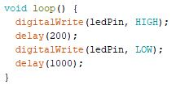 | 0.2S | 1S
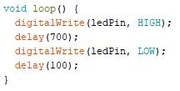 | 0.7S | 0.1S
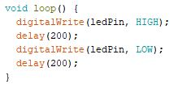 | 0.2S | 0.2S

Table 1

Discussion:

Discuss on the observed result.
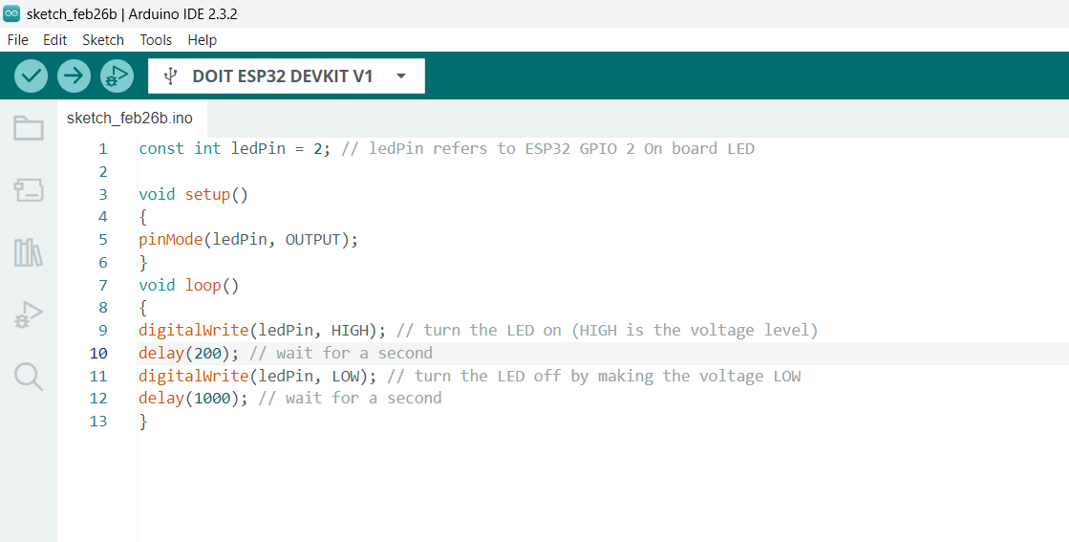
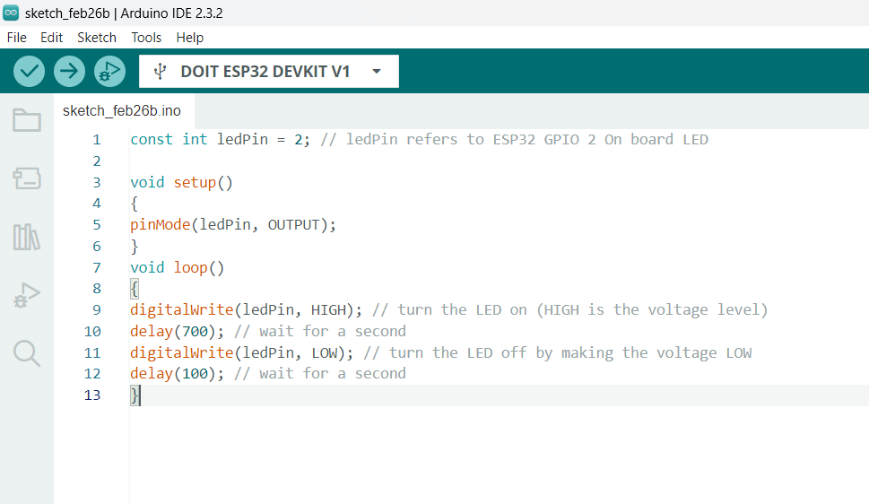

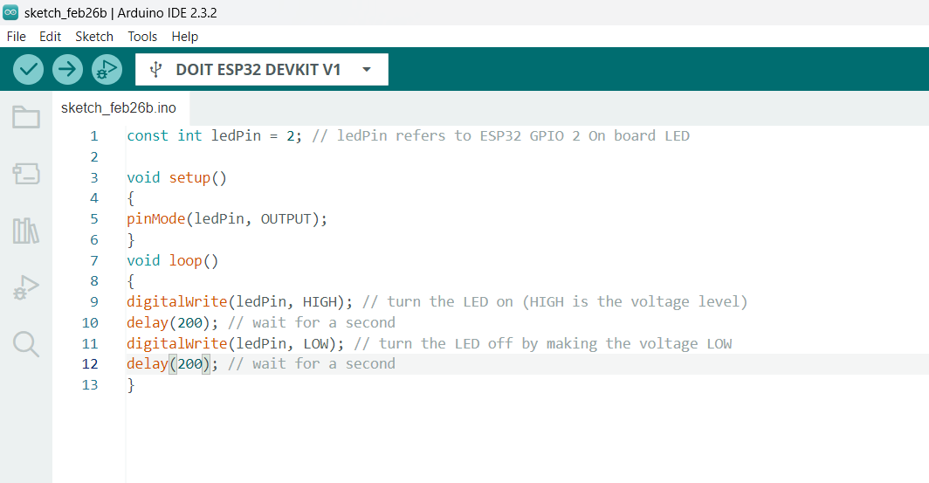

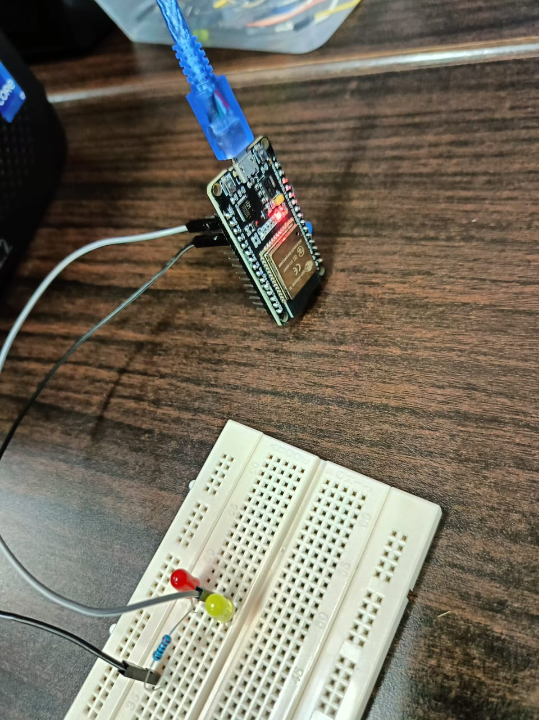

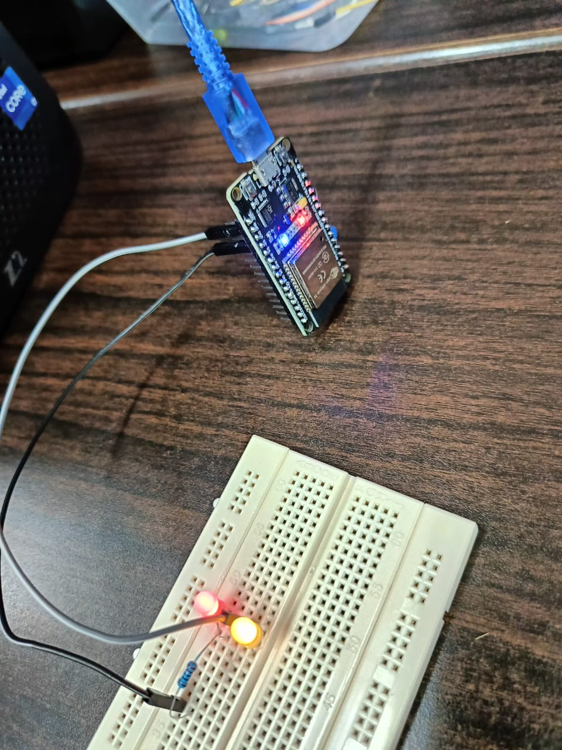
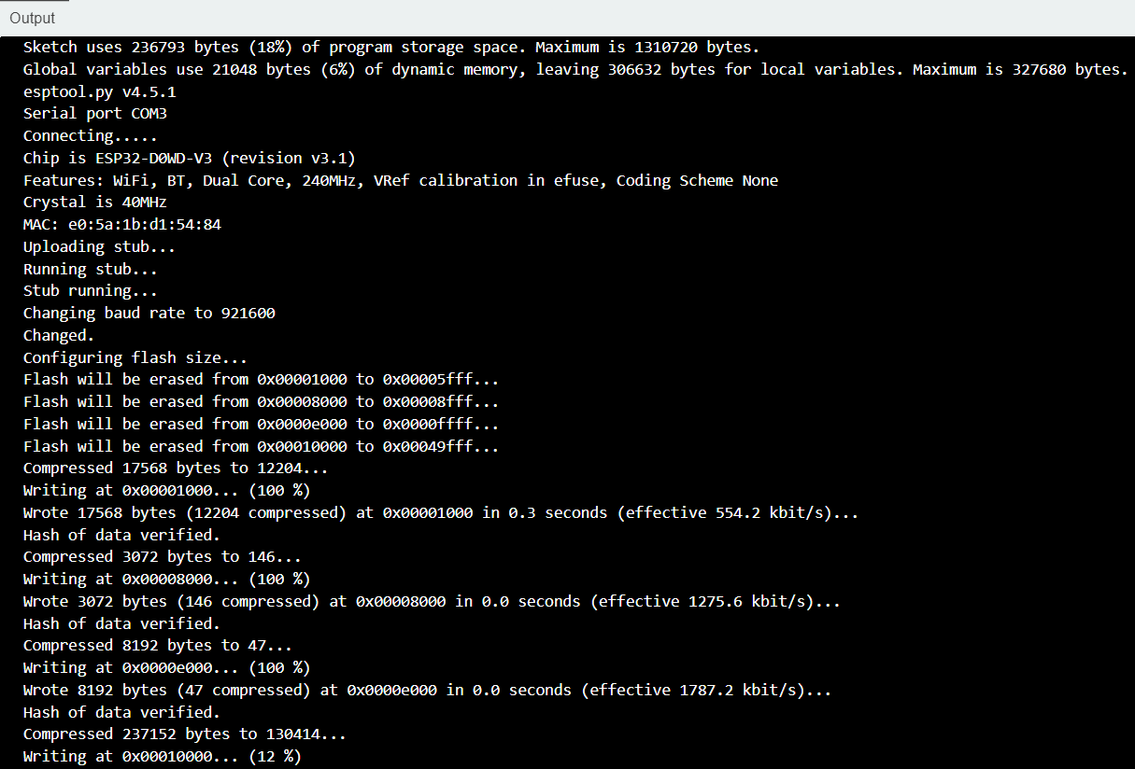\

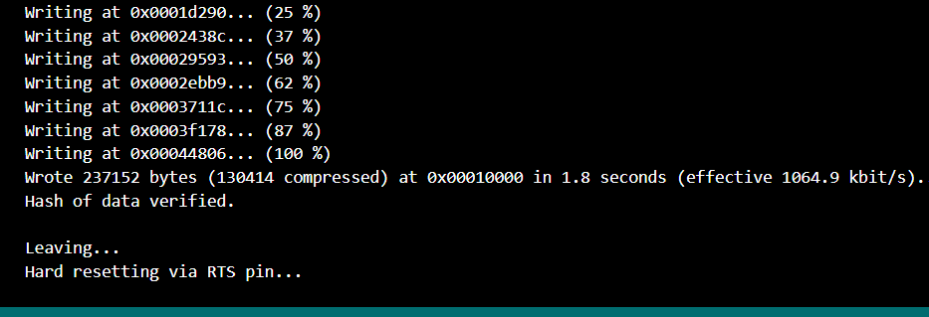
Conclusion:

Summarize whether the findings supported the hypothesis, possible sources of error, and what was learned from the experiment.

we can now Install and set up the Arduino IDE for the ESP32 board correctly. And also create a basic hardware connection, compile code, upload it to the ESP32, and perform successful testing. This hands-on experience provides a solid foundation for working with the ESP32 microcontroller.

